**Website development:**

**Tech stack selection:**

We have considered the following technologies to implement the E-Commerce website of our company:

* NextJS
* Joomla
* Wordpress

From all the selections, Wordpress has the fastest development to production time due to the availability of up to date Plugins and a very active developer echo system. Next, we checked the following themes for our website:

* Car dealer: <https://www.gorillathemes.com/wordpress/car-dealer-deluxe/go/2187/>
* WP-Automotive:<https://www.vwthemes.com/products/automotive-wordpress-theme/>
* Automotive: <https://www.gorillathemes.com/wordpress/automotive-car-dealership-wordpress-theme/go/2187/>

The “Car dealer” and “WP-automotive” themes have a built-in plugin for inventory management, which is an attractive feature. However, we plan to use “WooCommerce” as our E-Commerce plugin due to its attractive features and market place, where we can purchase the necessary inventory management modules for WooCommerce. Hence we have decided to go ahead with the WP-Automotive theme. This theme has responsive rendering for all the devices. Following are a few screenshots:

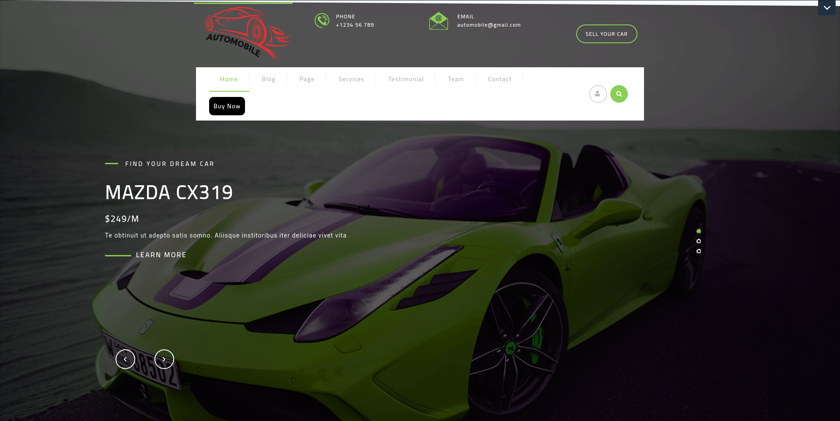

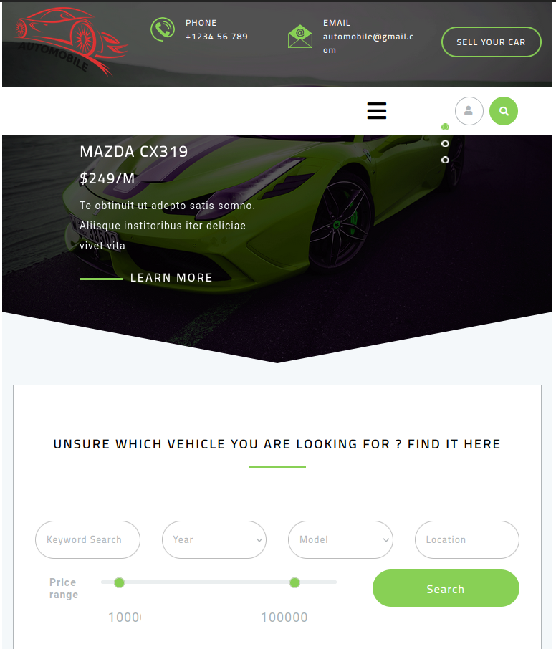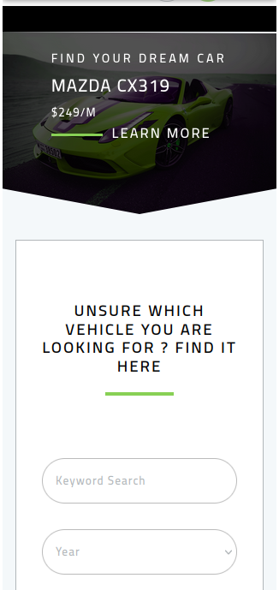

Apart from using WooCommerce for E-Commerce activities, we plan to use the following plugins:

* YOAST SEO Premium due to the additional features such as “5 keywords per page”, “Automatic redirects without 404” and “AI Optimized titles”.
* WP-Hide: To hide the fact that we are using Wordpress to deceive any potential attack.
* Wordfence: Web application firewall to prevent Wordpress based web attacks.
* MonsterInsights: For google analytics

**Content delivery**

As we target the customers world wide, it is important to serve the web pages efficiently. With respect to website optimization, we plan to implement image optimization using SMUSH Pro. This plugin provides cutting edge image optimization and high bandwidth image content delivery networks (CDN).

For hosting the site, we have decided to go with cloud server hosting (Virtual Private Server) instead of shared hosting. VPS provides better security and performance when compared to shared hosting, that comes with or without free CDN. This VPS will be coupled with Bunny CDN to distribute the content globally.

**Effective CTA**

CTA dictates how the presentation of the website encourages users to interact with the website and potentially become customers. Our CTA strategy is as follows:

* Vital CTA buttons like “Shop Now”, “Learn More”, or “Schedule a Test Drive”, appear at the top of the screen without making users scroll for them to see it.
* Place CTAs across all pages, with a focus on areas where individuals would be expected to take action after highlighting significant features about items or putting up comments by buyers.
* Maybe you should consider placing CTAs at the end of blog posts, articles and videos so that experts may direct their audience to the relevant company pages.
* Use colors on CTA buttons to contrast with the background. For instance, a good way of attracting attention is by employing yellow or bright red on a page filled mostly with shades of gray or black. Make sure the colors go with the company theme.
* Make the size of the buttons large enough to be easily clickable in both desktop and mobile devices, and at the same time not large enough to overshadow the content.
* Add sufficient white spaces around CTAs to declutter and give more focus to them, so that they can attract more attention.
* Use strong verbs like “Buy Now,” “Discover,” “Join,” “Get Started,” or “Explore” to encourage action.
* Find out what users will get when they click on the CTA button(cors benefit). Examples may include “Take a Test Drive Today,” “Electric Car Manual,” “Discount on First Purchase,” and so on.
* Incorporate urgency in order to make sure that you get an immediate response for an activity, for example a “Limited Time Offer”, “Only few Left” and “Exclusive Access”.
* "Use CTAs that look like they belong in the content they accompany. If you have a product page that could have “view full specs,” on it or a post in a blog about electric vehicles benefits with “learn more about our technology.”
* Data-driven personalization to modify CTAs based on the behavior of users such as displaying a "Continue Your Purchase" button for returning visitors who had earlier added items into their cart.

**Analytics integration**

For analytics, there are options such as Google analytics and open web analytics (OWA). OWA is open source and self hosted. However when it comes to benefits such as cutting edge AI prediction and information reliability, Google analytics outshines the other products, hence we decided to integrate google analytics to analyze our web traffic.

With google analytics we can get the number of visitors, page views, session duration, and bounce rate to understand overall website performance. Additionally, conversion tracking can help measure key actions such as purchases, form submissions, and sign-ups in order to estimate the success rate of the defined goals. Similarly e-commerce tracking allows us to gain insights into product performance, sales data and shopping behavior of the customers.

In order to integrate Google Analytics into our Wordpress site, we will use the MonsterInsights Pro version since, compared to the free version, it provides features to track e-commerce performance and this plugin seems to have better ratings. Additionally, when compared to free official plugins like Google Site Kit, this plugin provides more detailed insights using Google matrics. With respect to compliance requirements such as GDPR, MonsterInsights outshines Google Site Kit.

**Site Security**

We take multiple approaches to make sure the site, the payment system and data are secured appropriately. For security, as mentioned before, we will install the WP-Hide to obscure the wordpress site and Wordfence to protect the site from web attacks (SQLi, XSS, SSRF, XXE etc). If no plugin requires xmlrpc, we will disable it. For login, 2 factor authentication with application authenticator (e.g Google Authenticator) will be implemented. For encrypting the traffic, we will use SSL/TLS1.3 technology and the certificates will be obtained by “Let’s Encrypt” certificate authority.

For payment, we will integrate Stripe payment gateway with WooCommerce and the data will be frequently backed up and a disaster recovery system will be implemented to spin back the site as soon as possible, in case of a failure or a cyber attack. When storing the customer data, different compliance requirements such as GDPR will be satisfied.